**Jenkins**

Jenkins is primarily a build and Release Tool . They did not started with Continuous Integration Tool. But now a day’s Jenkins has a lot of Use.

[ In short: Jenkins is a continuous Integration Tool ]

**Jenkins is:**

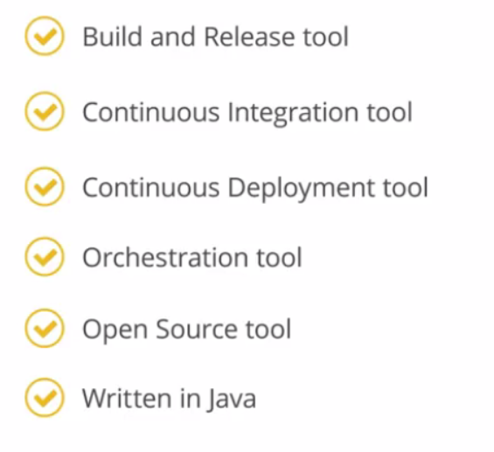

Who Uses Jenkins

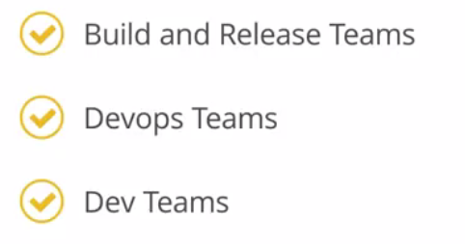

Why Jenkins

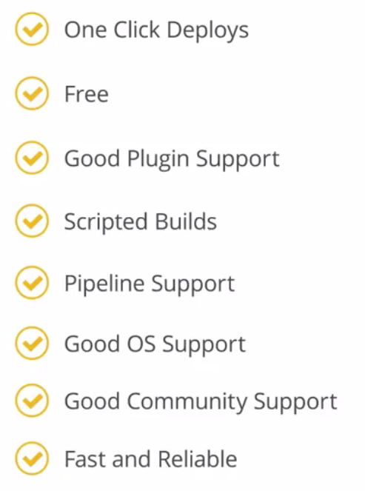

**Process before Continuous Integration tool**

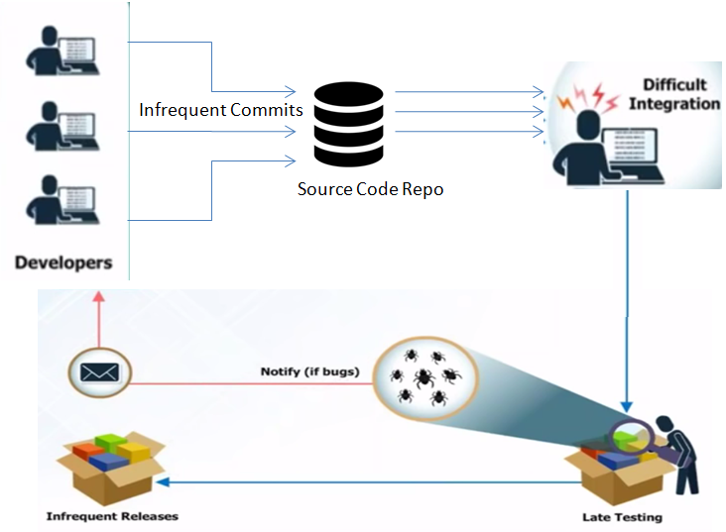

* Developers have to wait till the complete software is developed for the test results.
* If the test fails then locating and fixing bugs is very difficult. Developers have to check the entire source code of the software
* Software delivery process was slow. Developers have waste a lot of time to locate and fix a bug.
* Continuous feedback was not available for coding or architectural issues, build failures, test status etc.

**Continuous Integration** 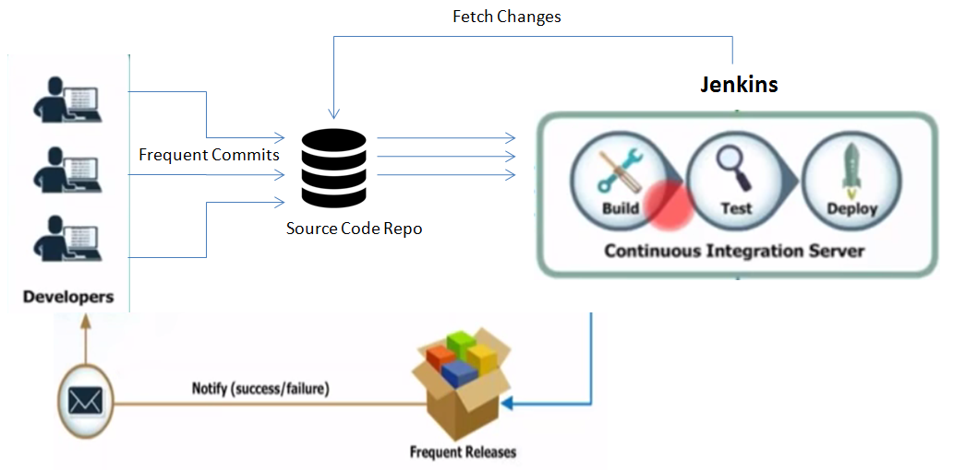

* Since after every commit to the source code an auto build is triggered and then it is automatically deployed on the test server.
* If the test results show that there is a bug in the code then the developers only have to check the last commit made to the source code.
* This also increases the frequency of new software releases
* The concerned teams are always provided with relevant feedback.

|  |  |
| --- | --- |
| **Before Continuous Integration** | **After Continuous Integration** |
| The entire source code was built and then tested. | Every commit made in the source code is built and tested. |
| Developers have to wait for test results | Developers know the test result of every commit made in the source code on the run |
| No Continuous Feedback | Continuous Feedback is present |

**What is Continuous Integration?**

Continuous Integration is a development practice in which the developers are required to commit changes to the source code in a shared repository several times a day or more frequently.

Every commit made in the repository is then built. This allows the teams to detect the problems early.

**Example of Continuous Integration Tools**

** **

** **

**What is Jenkins?**

Jenkins is an open source automation tool written in Java with plugins built for Continuous Integration purpose.

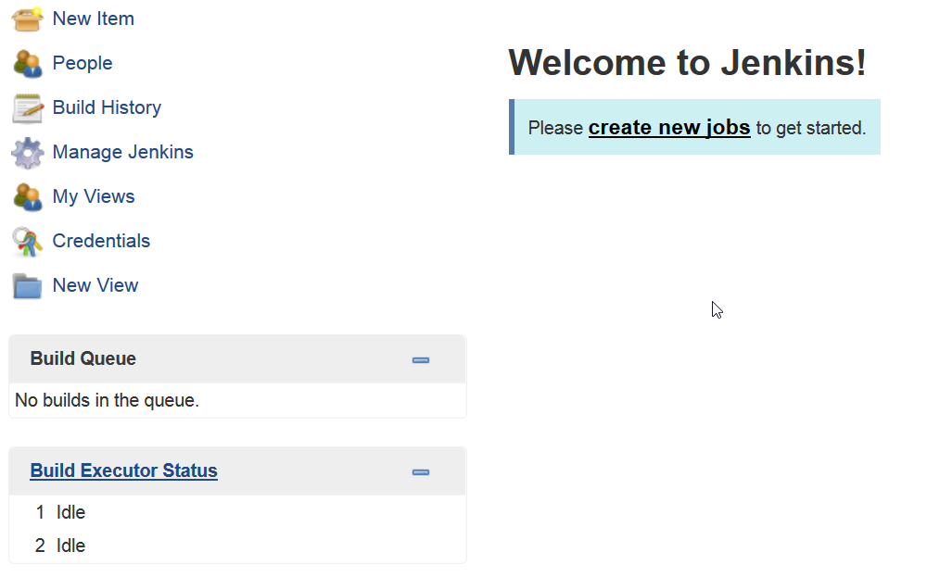**Creating Users in Jenkins**

**-----------------------------------------------------------------------------**

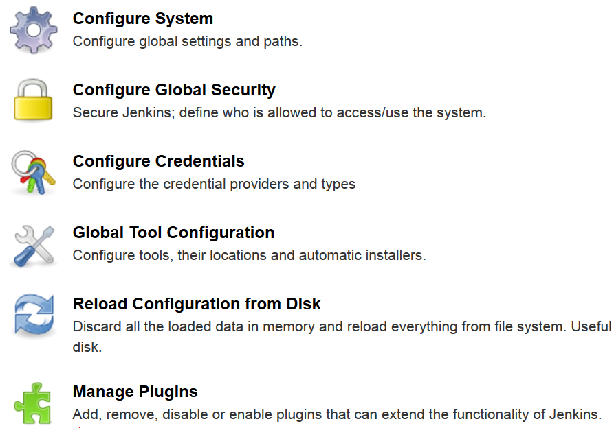

**-----------------------------------------------------------------------------**

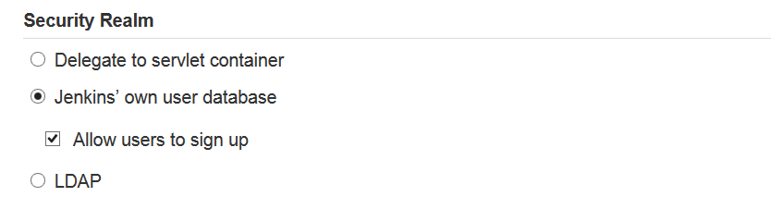

**-----------------------------------------------------------------------------**

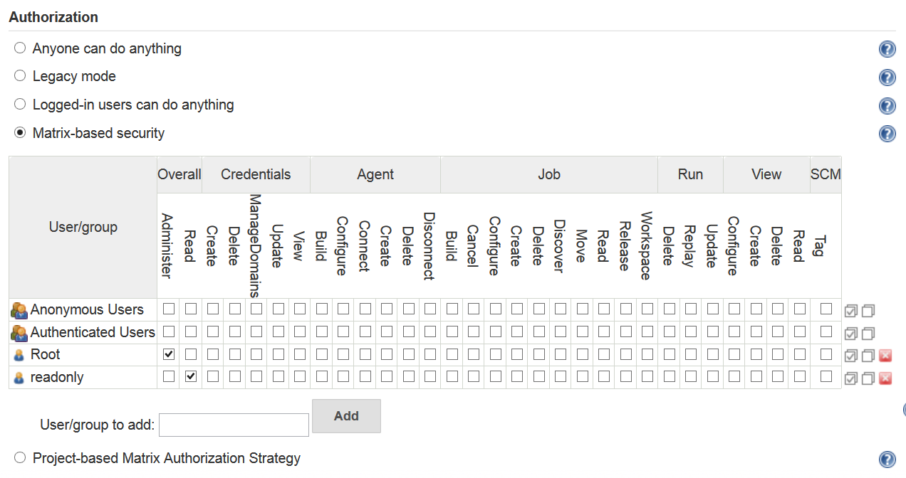

We can Add users and allow users for various permissions

**Installing a plugin in Jenkins:**

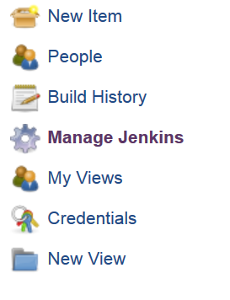

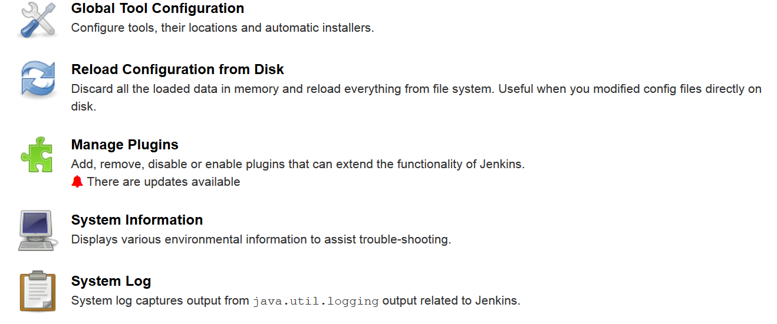

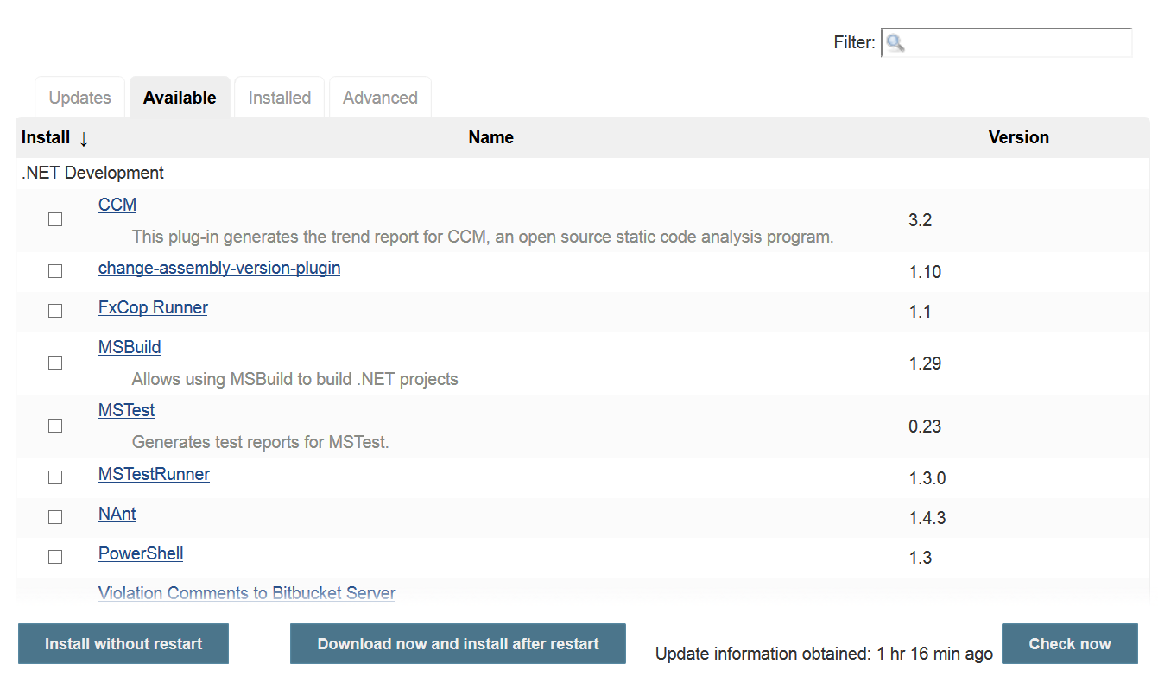

**Type the Plug-in Name here**

**Click on Available**

**Jenkins Plugins**

Jenkins supports plugin, which allow Jenkins to be extended to meet specific needs of individual project.

For Example:

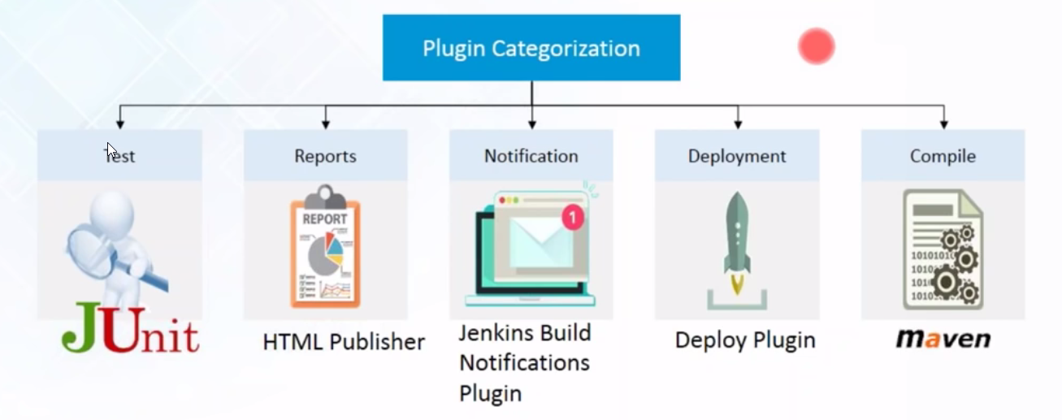

Require Plugins: pmd, build plugin

